Portfolio 1 - Documentation and Ethics Requirements

P Number: 2855274
Name: Zakaria Boutarfa
Individual Component: Stock Management System
Team Name: TeamTwo

Contents
1. Documentation 3
1.1 Team Class Diagram 3
1.2 Individual Use Case Diagram(s) 4
1.3 Individual Use Case Descriptions 5
2. Ethics Case Study 15
2.1 Risk Register 15
2.2 Ethics Checklist 16
3. References 17

Documentation

Team Class Diagram

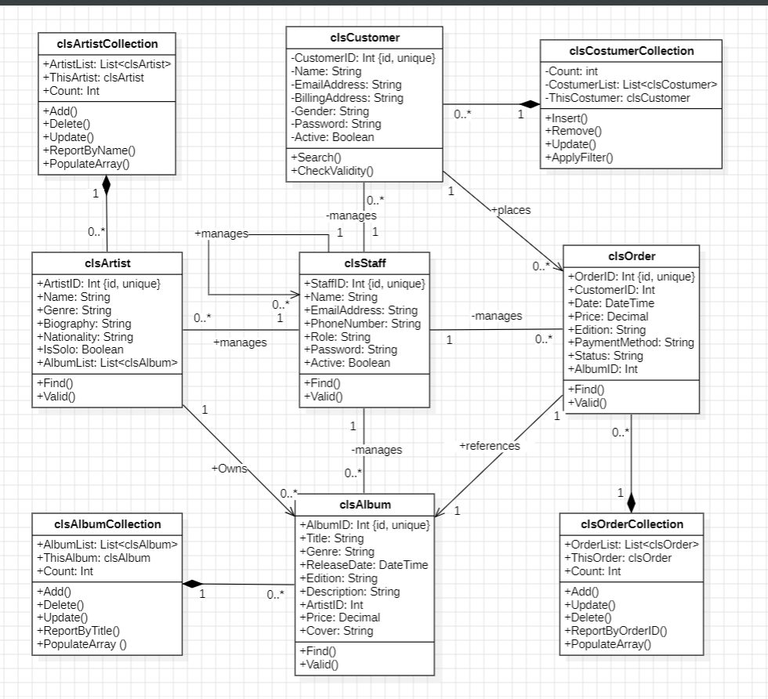

Individual Use Case Diagram(s)

Top level system Use Case diagram:
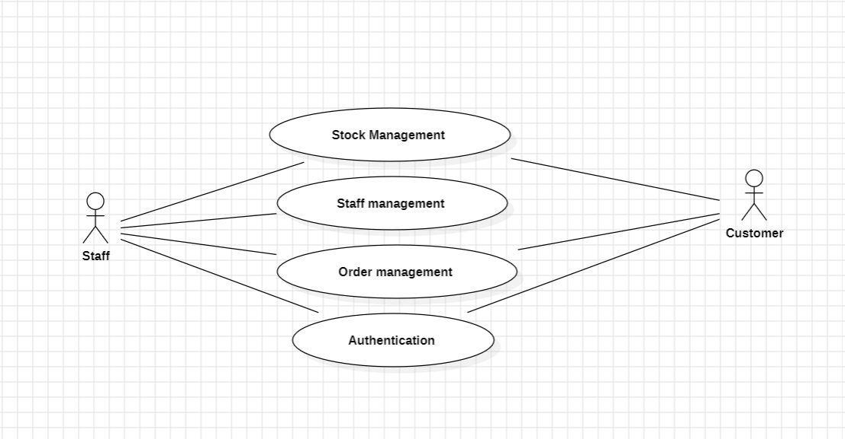
Stock Management Use Case diagram:
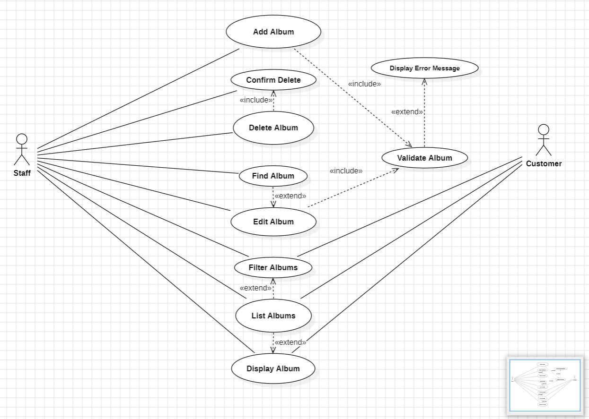

Individual Use Case Descriptions

Use Case Name | Add Album
Use Case Author(s) | Zakaria Boutarfa
Primary Actor(s) | Staff member
Other Stakeholders | Customers, Database system
Business Goal | Allows staff to add a new album record into the album list, that is used by customers to display and album and potentially make a purchase.
Preconditions | In data entry page where the add button is, the staff member must be logged into his account for authorization level matter.
Success Condition | A new album record is added in the database table dedicated to albums, as well as in the album list available to customers. An album ID is also attributed to this new album.
 | Actor | System
Primary pathway | 1.Staff member is logged in. | 2.staff privileges granted
 | 3. Click on Add button from list page | 4. Redirected to the data entry page
 | 5. Staff member fill in album information. | 6. Validation method checks that input is in correct format and within range of acceptable data.
 | 7.Click on OK button | 8. Saves album in database and shown in album list in album page.
Alternate pathways | - Staff member fills in only required data fields (that do not accept NULL values). | 4a. New record is added, with missing information but not critical.
Exception pathways | - Staff member enters invalid data  - Connection to database fails  - Non-staff member or not logged in staff tries adding a new record. | - label error displays appropriate message.  - Redirect to list page, however new record won’t appear.  - Redirect to list page, however new record won’t appear.

Use Case Name | Validate Album
Use Case Author(s) | Zakaria Boutarfa
Primary Actor(s) | Staff member
Other Stakeholders | Customers, Database system
Business Goal | Is used along with Add and Edit use cases, it is used to check that data fields are following wanted data format and within range of data values. It also displays appropriate error message according to which field(s) cause issue(s).
Preconditions | In data entry page, a staff member needs to be logged in and clicked on OK button for the validation to occur.
Success Condition | Allows the add/edit for good data, displays appropriate error message for bad data
 | Actor | System
Primary pathway | 1.Staff member is logged in. | 2.staff privileges granted
 | 3. Click on Add button from list page | 4. Redirected to the data entry page
 | 5. Staff member fills in album information. | 6.
 | 7.Click on OK button | 8. Allows the addition of the new record in good data case.
Alternate pathways | - Staff member fills in required fields, with incorrect format or out of valid data values range | 4a. Displays an error message related to field(s) causing issue(s)
Exception pathways | N/A | N/A

Use Case Name | Find Album
Use Case Author(s) | Zakaria Boutarfa
Primary Actor(s) | Staff member
Other Stakeholders | Customers, Database system
Business Goal | Used to retrieve an album information based on its ID number, mainly used to edit an existing album which will update database and change album information customer see.
Preconditions | In Data Entry page, a staff member needs to be logged in, a valid and existing AlbumID integer needs to be filled in.
Success Condition | Display the corresponding album information.
 | Actor | System
Primary pathway | 1.Staff member is logged in. | 2.staff privileges granted
 | 3. Enters a valid and existing AlbumID integer that corresponds to a real Album in our database | 4. //
 | 5. Click on Find | 6. Displays Album information
Alternate pathways | - Click on find button without filling in AlbumID field  - Number put in AlbumID refers to non-existing record in database | a. Displays error message suggesting entering a number  b. An error message is displayed informing staff member that there is no such record in database.
Exception pathways | - Filling AlbumID field with wrong datatype i.e. alphabetical letters | - Error message displayed suggesting the correct datatype

Use Case Name | Delete Album
Use Case Author(s) | Zakaria Boutarfa
Primary Actor(s) | Staff member
Other Stakeholders | Customers, Database system
Business Goal | Used to delete an album record from both database and list page visited by customers.
Preconditions | In list page, a staff member needs to be logged in to use the delete button.
Success Condition | Successfully deletion of selected record from database and album list in list page.
 | Actor | System
Primary pathway | 1.Staff member is logged in. | 2.staff privileges granted
 | 3. Click on an album record from album list in list page | 4.
 | 5. Click on Delete button | 6. Redirect to delete confirmation page
 | 7.Click on Yes button | 8. Allows the deletion of selected record from database and album list in list page
Alternate pathways | - In delete confirmation page, click on NO  - No selected record upon clicking on Delete button | a. Cancels deletion procedure and keeps selected album record  b. An error message is displayed requesting to select a record user wants to delete.
Exception pathways | - Staff member is not logged in, and clicks on Delete button | - Nothing happens, user has not permission to perform that action

Use Case Name | Confirm Delete
Use Case Author(s) | Zakaria Boutarfa
Primary Actor(s) | Staff member
Other Stakeholders | Customers, Database system
Business Goal | Used to confirm and final step for deletion procedure, allows to delete a record from database and list page, which is consulted by customers
Preconditions | In list page, a staff member selected an album record and clicked on Delete Button
Success Condition | Successfully deletion of selected record from database and album list in list page.
 | Actor | System
Primary pathway | 1.Staff member is logged in. | 2.staff privileges granted
 | 3. Click on an album record from album list in list page | 4.
 | 5. Click on Delete button | 6. Redirect to delete confirmation page
 | 7.Click on Yes button | 8. Allows the deletion of selected record from database and album list in list page
Alternate pathways | - In delete confirmation page, click on NO  - No selected record upon clicking on Delete button | a. Cancels deletion procedure and keeps selected album record  b. An error message is displayed requesting to select a record user wants to delete.
Exception pathways | - Staff member not logged in, and clicks on Delete button | - Nothing happens, user has not permission to perform that action

Use Case Name | Edit Album
Use Case Author(s) | Zakaria Boutarfa
Primary Actor(s) | Staff member
Other Stakeholders | Customers, Database system
Business Goal | Allows staff to edit an album record information by using find method, which will update database table and therefore information perceived by customers
Preconditions | In data entry page where the edit button is, the staff member must be logged into his account for authorization level matter.
Success Condition | The selected album record information are updated in the database table dedicated to albums, for customers to read as well.
 | Actor | System
Primary pathway | 1.Staff member is logged in. | 2.staff privileges granted
 | 3. An album record is selected in album list | 4.
 | 5. Click on Edit button from list page. | 6.Redirected to Data entry page and selected album record information are displayed corresponding fields.
 | 7. Staff member fills in updated album information. | 8. Validation method checks that input is in correct format and within range of acceptable data.
 | 9. Click on OK button | 10.Album information are updated in database and presentation layer.
Alternate pathways | - Staff member fills in only required data fields (that do not accept NULL values).  - Staff member does not select an album from album list to edit.  - Staff member does not change any information. | - record is updated, with missing information but not critical.  - An error label displays appropriate message.  - Album updated with identical information.
Exception pathways | - Staff member enters invalid data  - Connection to database fails  - Non-staff member or not logged in staff tries | - label error displays appropriate message.  - Redirect to list page, however new record won’t appear.  - Redirect to list page, however new record won’t appear.

Use Case Name | List Album
Use Case Author(s) | Zakaria Boutarfa
Primary Actor(s) | Customer
Other Stakeholders | Staff members, database system
Business Goal | Used to list all available album records, used mainly to search and display further album information in another page for customers. For staff, is used to delete, add and edit albums.
Preconditions | Entered list page.
Success Condition | Display the available album records.
 | Actor | System
Primary pathway | 1.Enters list page from main menu | 2.Displays all album records.
Alternate pathways | - No album record is available | - A message is displayed to inform.
Exception pathways | - N/A | - N/A

Use Case Name | Filter Albums
Use Case Author(s) | Zakaria Boutarfa
Primary Actor(s) | Customers
Other Stakeholders | Staff, Database system
Business Goal | Allows both Customers and staff members to filter album records according to their titles displayed in the album list for more convenience.
Preconditions | Is in List page
Success Condition | Album list displays albums that meet filter criteria.
 | Actor | System
Primary pathway | 1.Enters list page from main menu | 2.Original complete list is displayed.
 | 3. Type full title name of the album targeted | 4.
 | 5. Click on Apply button | 6. Album with matching title name appear on the album list
 | 7.Click on Clear button | 8.Original complete list is displayed again and filter field erased.
Alternate pathways | - Type only a part of the title name of the album  - Not clicking on apply button. | - System shows all albums that start as the filter text field.  - Nothing happens, original list still displayed.
Exception pathways | - No matching album | c. Album list is left blank and relevant error message is displayed.

Use Case Name | Display Album
Use Case Author(s) | Zakaria Boutarfa
Primary Actor(s) | Customers
Other Stakeholders | Staff, Database system
Business Goal | Allows customers and staff to select an album from album list in list page and get further information about the record in another page that also offers the option to place an order which would affect database order table.
Preconditions | Is in list page
Success Condition | User is redirected to another page that displays appropriate information of the selected album.
 | Actor | System
Primary pathway | 1.Enters list page from main menu | 2.Album list displayed
 | 3. An album record is selected in album list | 4.
 | 5. Click on Display button from list page. | 6.Redirected to Display page and selected album record information are displayed correctly.
Alternate pathways | - Staff member does not select an album from album list to display. | - An error label displays appropriate message.
Exception pathways | N/A | N/A

Ethics Case Study

Risk Register
Risk Assessment
H | High-unacceptable risk; major disruption likely; different approach required; priority management attention required.
M | Moderate risk; some disruption; different approach may be required; additional management attention.
L | Low/minimum risk; minimum oversight needed to ensure risk remains low

Scoring: IMPACT LIKELIHOOD (L)
1 = Insignificant 1 = Rare
2 = Minor 2 = Unlikely
3 = Moderate 3 = Possible
4 = Major 4 = Likely
5 = Catastrophic 5 = Almost Certain

Risk | Likelihood | Impact | Proposed risk-mitigation measure
Unauthorized database access | H2 | L5 | Implement secure protocols with hashed passwords and enforce strong policies regarding passwords (minimum length, use of special characters). Also, restrict casual user to only read permissions.
Stock data deleted | H2 | L4 | Keep backup database date and regularly update them. For example, once a week as album records come out usually every week’s Friday. So, we may implement database backup update every Friday.
Album Cover missing | M3 | L2 | Implement a default Cover Image in cases of missing or invalid image URL.
Misuse of Admin functionality | H2 | L5 | Make sure to check that staff member is logged in to use a staff-level authorization method. For example, restrict update functionality that can break database data integrity to logged in staff.
Album list fails to load | H2 | L4 | Display error message to inform user and test in middle layer list display logic (re-run tests).
Invalid AlbumID breaks key methods. | H1 | M3 | Put in place a solid validation around AlbumID attribute, as it is used as main link between layers.  Display appropriate error message for wrong data.
Two staff edit album at same time | H2 | L4 | Add edit lock system that lets only one logged in staff member to edit a specific album at a time. It is used to ensure clarity and integrity in database data.
Album sold out | H4 | L3 | Implement stock check by staff to make sure albums are available for customers. If not, re-order album stock and momentarily remove album from album list.
Duplicate albums | H4 | L2 | Implement ‘UNIQUE’ constraints in Add method logic
Wrong album information | H3 | L4 | Human induced errors during data entry. For example, non-corresponding price, artist or release date. It can be coped with by implementing a staff double check after an add/edit. In addition, implement a button for customers to report any missed error.

Ethics Checklist

Key Principle | Rationale | How has it been addressed or could be addressed
Transparency: Transparency is essential in the development of ethical software. | This means users should understand how their data is collected, processed, and stored. As a developer, you should offer clear and accessible documentation regarding your software’s capabilities, limitations, and potential risks. This openness creates trust between developers and users, allowing them to make informed decisions about their data and engagement with the platform. | The system will include a page that explains in detail how album data is stored, used and modified (title, artist, release date etc…). On top of that, the page will explain which staff members can change those data. For more transparency and clarity, the system will eventually keep log actions, which are saved records of actions made by staff members and the moment changes were made. Actions may be adding records, editing or even deleting albums. This helps making everything traceable, so misuses can be found and corrected.  (IEEE Code of Ethics #5)
Privacy: Privacy is a fundamental right software must respect. | As a developer, you should only collect the data required for your application’s intended purpose following the data minimization principles and acquire informed consent from users. | The Stock management system will collect almost no data from users, it will mainly use data collected by the authentication system, which will make sure to collect only critical necessary information (i.e. address, email address) for billing and confirmation purposes. Users will be informed upon registering of the conditions and asked for permissions first. Also, stock management system will use a very simplistic range of data related to albums and artists which are all available on Internet via permissions of rights holders.  (BCS Code of Conduct section 1(c)).
Security: In ethical software development, security is paramount | Software should be planned and produced throughout the development lifecycle, with security a high concern. Developers should follow best practices to identify, avoid, and mitigate vulnerabilities. | The stock management system will ensure security by using secure database connections (SQL Connect) which will protect database credentials which are extremely sensitive information. It will also protect the system from attacks that are based on input into fields by adding appropriate and necessary validation on inputs. On top of that, only staff members with granted permission will be able to alter album table in database. Sensitive customer and album data will be protected by another layer of encryption.  (ACM Code of Ethics 2.9)
Fairness: Fairness ensures that software does not discriminate against any group or individual. | Algorithms and decision-making processes should be free of bias and not increase or perpetuate social and economic imbalances. Developers must use approaches to discover and reduce biases in algorithms and data. | The system will also equally showcase album records regardless of their genre, music label or artist. This will make independent artists thrive and reach an unexpected audience and stand out. Customers will still be able to reach directly to a specific album/ genre/ artist by using the filter method, such that it remains user choice and not hardcoded to avoid interest conflict.  (BCS Code of Conduct section1(a)).
Accountability: The effects of software on people and society are the responsibility of its developers. | As developers, we must be accountable for any unfavourable outcomes and be open and honest about growth procedures. Clear methods for reporting ethical concerns should be established, and any ethical issues should be addressed as soon as possible | should be. As said in Transparency section, the system will include action logs which tell by who, what and when an action has been made. This will help identify responsible staff member, which method caused issue (edit, add or delete). Once these information gathered, it is very important to have staff members ready to fix any unexpected bug or issue. They would proceed methodologically by using prior made procedures to overcome common problems. Otherwise, they can prevent a problem to become even worse. On top of that, the system will regularly have updates to fix bugs. Stored backups can also be very helpful for undoing mistakes that do not exist in previous versions.  (IEEE Code of Ethics #7)
https://blog.openreplay.com/ethical-considerations-in-software-development/

References

- Association for Computing Machinery (ACM), 2022. ACM Code of Ethics and Professional Conduct. Available at: https://www.acm.org/code-of-ethics .
- British Computer Society (BCS), 2022. BCS Code of Conduct. Available at: https://www.bcs.org/media/2231/bcs-code-of-conduct.pdf .
- Institute of Electrical and Electronics Engineers (IEEE), 2022. IEEE Code of Ethics. Available at: https://www.computer.org/education/code-of-ethics
- StarUML, 2025. StarUML Documentation. Available at: https://docs.staruml.io/ .
- Cletus, 2023. Ethics Checklist – Computing Coursework Explained. Available at: https://youtu.be/6XrL5jXmTwM .

